**8.5 Task: Comparing Student Responses to a Regents Question**

Regents Question: *(2 points)*

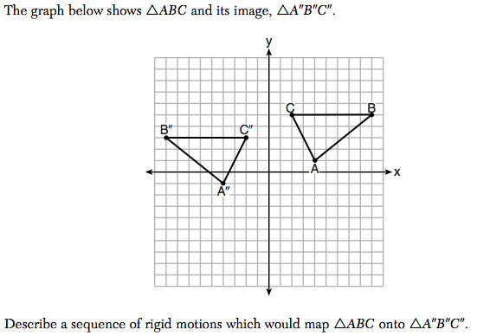

**Task:**

Score the following student answers from 0-2 points and justify your score to the right of their answer in ONE sentence.

**Student A’s answer: Score: ______ Justification:**

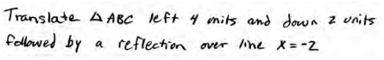

**Student B’s answer: Score: ______ Justification:**

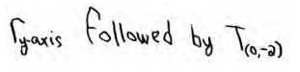

**Student C’s answer: Score: ______ Justification:**

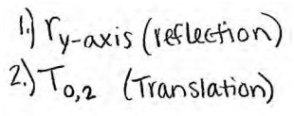

**Student D’s answer: Score: ______ Justification:**

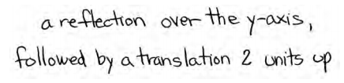

**Student E’s answer: Score: ______ Justification:**

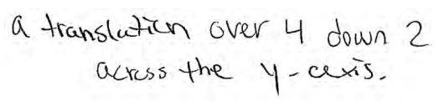

**8.5 Compositions of Isometries Classwork & HW**

*On the side of every graph, write down what the transformation rule is stating (i.e. first a reflection over … then by a translation of …)*

**1.**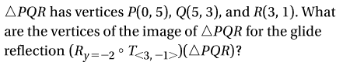



2.   
Triangle PNB has vertices at the following points: P(2,2) N(3, -1) B(-1, -2)

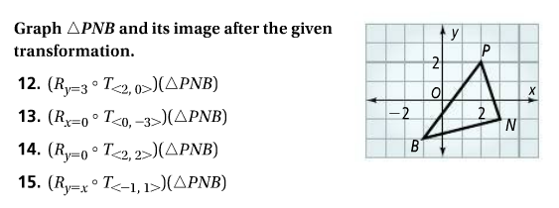



3.

Triangle PNB has vertices at the following points: P(2,2) N(3, -1) B(-1, -2)







4.

Triangle PNB has vertices at the following points: P(2,2) N(3, -1) B(-1, -2)







5.

Triangle PNB has vertices at the following points: P(2,2) N(3, -1) B(-1, -2)







